App proposal

user + app research

empthy map

user journey

Needs:

directly by the user traits note

contrdictions between two traits

e.g. disconnect between what one said and what one did

Insights

-distinction that you could everage

-come from contradictions

-asking "why" a person did somthing

Include Persona: A user model, some visual representation that user with the data collected

-face, name, story, ambition, objectives, desires

-fiction pattern common to all user

-at least 1, no more than 3

POV point of View

-reframing your design challenge into an actionable problem statement that will launch you into ideation

-a unique, concise retraming of the problem that is grounded in user insights+needs

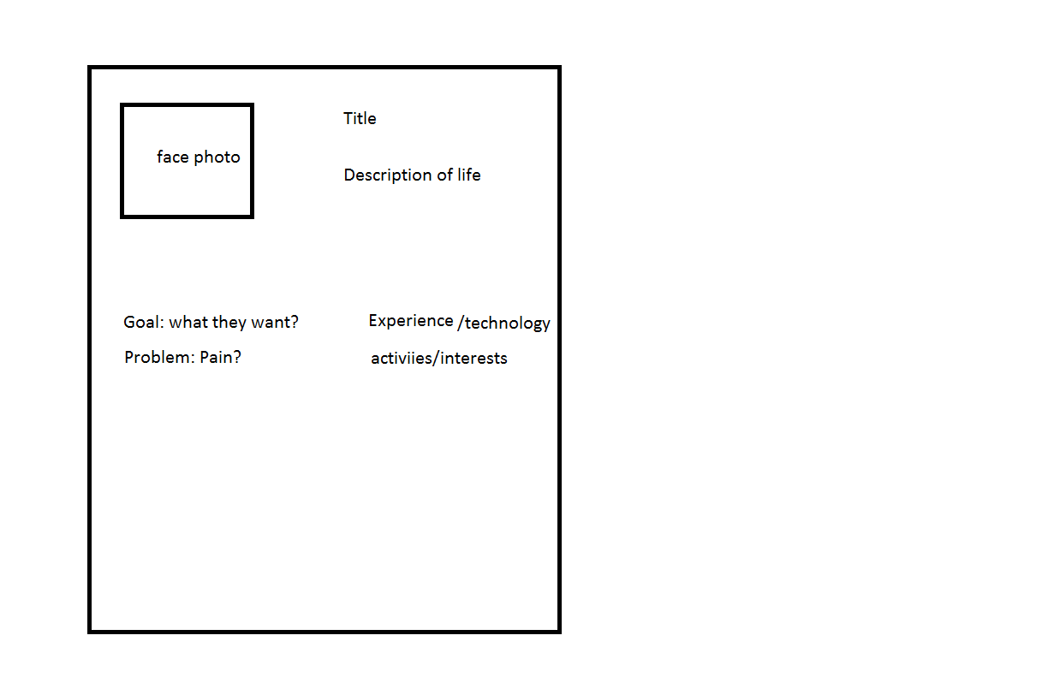

Embrace POV

1.user [we met ....someone]

2. need [we were suprised to discover...problem]

3. Insight [It would change the world if....we design something]

POV

[user] need to [user need] because [suprising insight]

\*metaphors可有可无

User journey/Journey map

-How user model/ persona behaves and feels when they have a certain goal in a specific context

-visual way of comprehending process a persona embarks on from the moment need arises to the second the need is satisfied using the app

-Eg. Someone gets lost, how to get home using phone?

-consider under each situation:

1.When they get lost

2. before opening the app

3. The time they use the app to go home

-go through each actions

-visualized graphically in a linear representation

-Stages: show emotion +difficulties in each step

-Actions required throughout

Need alierachy: not all needs are equal

Common

Context: share in same group

Activity:

Visualize happening